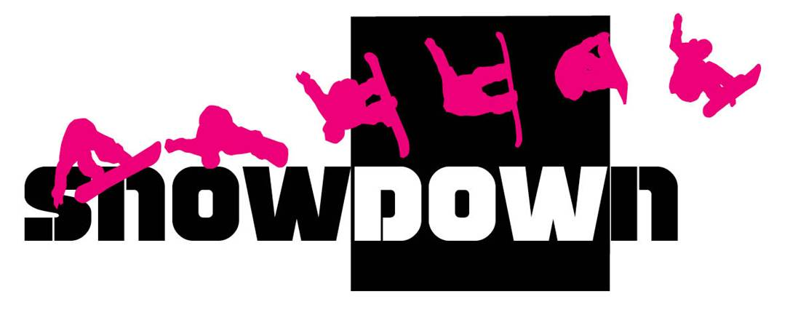**SNOWBOARDEN BEGINNERS**

www.abc-of-snowboarding.com/learn-snowboarding/

[[Skating](http://www.abc-of-snowboarding.com/learn-snowboarding/skating.asp)](http://www.abc-of-snowboarding.com/learn-snowboarding/skating.asp)

[Skating](http://www.abc-of-snowboarding.com/learn-snowboarding/skating.asp)

Learn Skating so you can move through flat areas or terrains and get on and off the chairlift with ease. Watch our animation and get some Snowboarding Tips.

[[Switching Edges](http://www.abc-of-snowboarding.com/learn-snowboarding/switching-edges.asp)](http://www.abc-of-snowboarding.com/learn-snowboarding/switching-edges.asp)

[Switching Edges](http://www.abc-of-snowboarding.com/learn-snowboarding/switching-edges.asp)

This Snowboard Exercise will teach you how to switch edges with both feet strapped in. Just use our animation as your guide as you move from one edge to the other.

[[Sideslipping (Heelside)](http://www.abc-of-snowboarding.com/learn-snowboarding/sideslipping-heelside.asp)](http://www.abc-of-snowboarding.com/learn-snowboarding/sideslipping-heelside.asp)

[Sideslipping (Heelside)](http://www.abc-of-snowboarding.com/learn-snowboarding/sideslipping-heelside.asp) and (Toeside)

Sideslipping is a controlled slide along the Fall line of a slope. This will teach you how to use the heel edge of your Snowboard in controlling your descent.

[[Traversing (Heelside)](http://www.abc-of-snowboarding.com/learn-snowboarding/traversing-heelside.asp)](http://www.abc-of-snowboarding.com/learn-snowboarding/traversing-heelside.asp)

[Traversing (Heelside)](http://www.abc-of-snowboarding.com/learn-snowboarding/traversing-heelside.asp) and (Toeside)

Traversing will teach you how to control your speed and improve your balance while on the slope. You can start doing Heelside Traverses. This section will show you how.

[Falling Leaf](http://www.abc-of-snowboarding.com/learn-snowboarding/falling-leaf.asp)

As the name suggests, the Falling Leaf is similar to the movement of a leaf that falls from a tree. The difference is that this Snowboard Exercise involves a change in direction.

[[Garlands](http://www.abc-of-snowboarding.com/learn-snowboarding/garlands.asp)](http://www.abc-of-snowboarding.com/learn-snowboarding/garlands.asp)

[Garlands](http://www.abc-of-snowboarding.com/learn-snowboarding/garlands.asp)

Garlands are called as such because the traces that you will leave on the snow are similar to garlands that you see in Christmas trees. Read on and learn how to do this exercise.

[[Linking Turns](http://www.abc-of-snowboarding.com/learn-snowboarding/linking-turns.asp)](http://www.abc-of-snowboarding.com/learn-snowboarding/linking-turns.asp)

[Linking Turns](http://www.abc-of-snowboarding.com/learn-snowboarding/linking-turns.asp)

Linking Turns is the final step in our online course where you combine all you have learned. At this point, you should already know some essential factors such as Snowboard control and edge awareness.